The Hardware Required for Robot are,

1. Bot circuit
2. Slate circuit

**The components of Bot Circuit are,**

1. Arduino Controller
2. Touch Sensor
3. Rain Sensor
4. Sound Detection Circuit
5. Object Detection Circuit
6. Motor Driving Circuit
7. Buzzer
8. IR Receiver Circuit
9. LDR Circuit
10. Eye LED
11. Debugging LED
12. RF Receiver Circuit
13. **Arduino Controller:**

Arduino is open source hardware and software company, project and user community that designs and manufactures single board microcontrollers and microcontroller kits for building digital devices. The Arduino board provide 14 digital I/O pins and 6 analog pins with 5 V linear Regulator and 16 MHz Crystal oscillator.

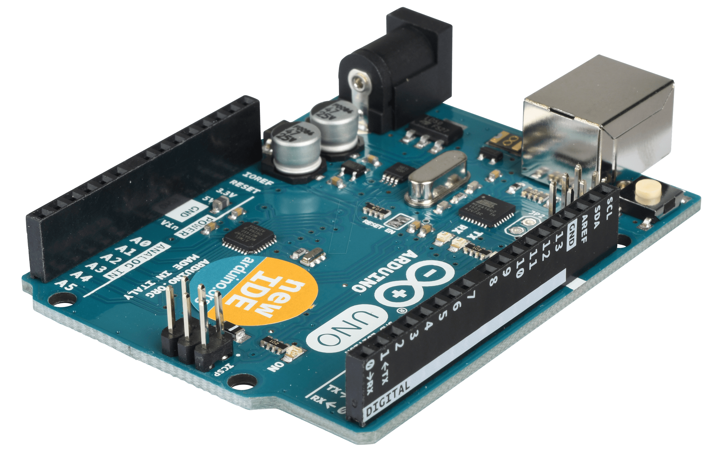

Arduino Controller Board

1. **Touch Sensor:**

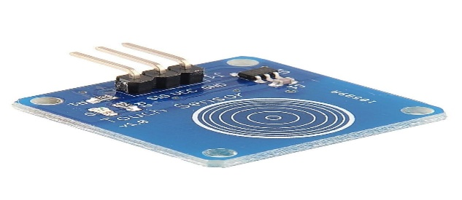 A touch sensor is a type of switch that only has to be touched by an object to operate. It is used in many lamps, walls and robots switches that have a metal exterior. A touchscreen includes an array of touch switches on a display. A touch switch is simplest kind of tactile sensor.

Touch sensor

1. **Rain Sensor:**

A rain sensor or a rain switch is a switching device activated by rainfall. The sensor is used to protect the robot from rain and support automatic mode of robot. The rain sensors are based on Total Internal Reflection.

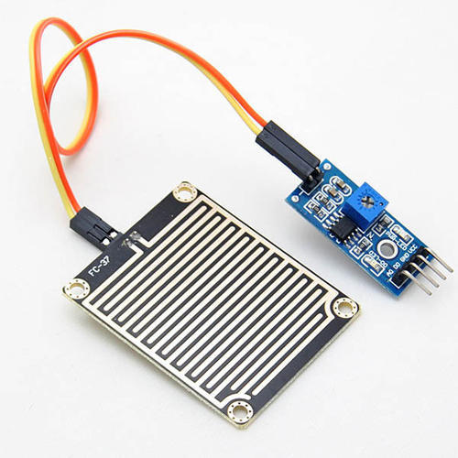

Rain Sensor

1. **Sound Detection sensor:**

A Sound detection sensor can detect sound intensity but cannot recognize the specified sound. Inside the sensor, there is sound sensitive electret – condenser microphone. Acoustic wave triggers vibration of the thin electret film and causes capacitance change, generating subtle voltage. The voltage is converted into 0-5 V.

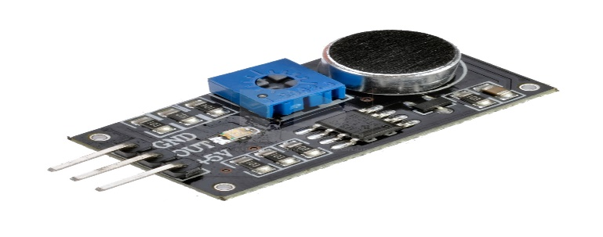

Sound Detection Sensor

1. **Object Detection Sensor:**

Object Detection Sensor able to detect nearby objects without any physical contact. Infrared Obstacle sensor module has IR transmitter and IR receiver that sends out IR energy and looks for reflected IR energy to detect presence of any obstacle.

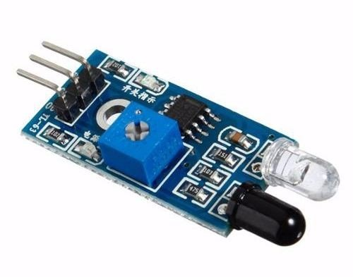

IR Object Detection Sensor

1. **Motor Driving Circuit:**

Motor driver IC is an integrated Circuit chip used to control motors in autonomous robots. Drivers act as an interface between microprocessors in robots and motors in robot. The most commonly used IC is LM293D. It is quadruple high current half H bridge drivers. It is designed to provide bi directional drive current upto 600mA at voltage of 4.5 V to 32 V.

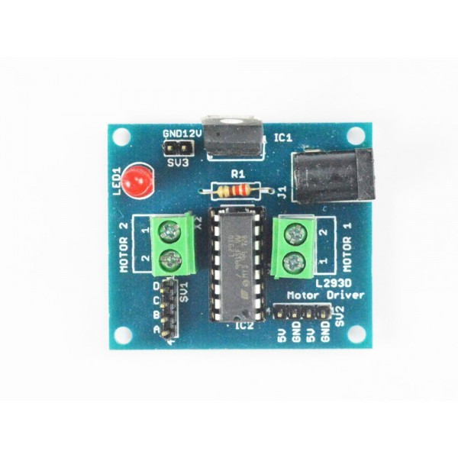

Motor Driver Circuit

1. **Buzzer:**

A buzzer or beeper is an audio signaling device, which may be mechanical, electromechanical or piezoelectric. Typical use of buzzers are alarm devices, timers, and confirmation of user input as a mouse click or keystroke. It work with DC current of 20mA at 1.5 – 12 V.

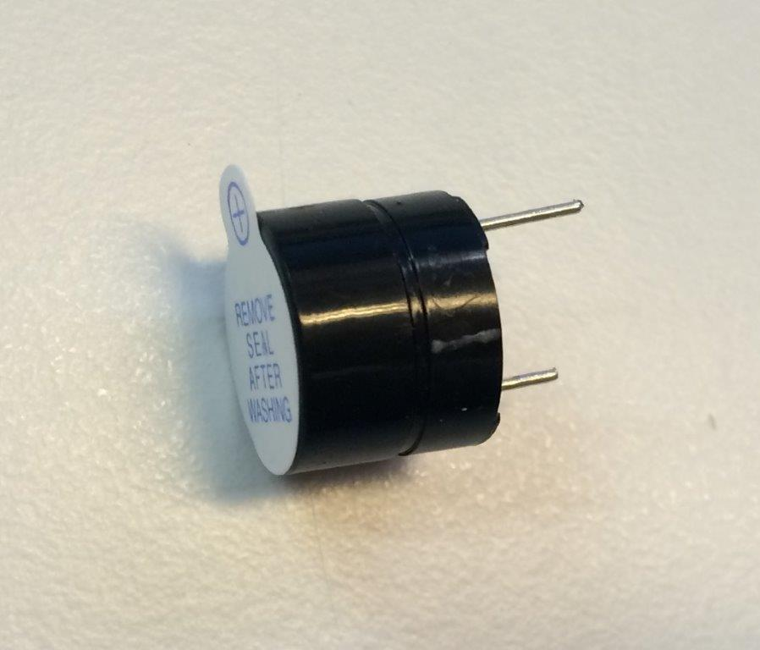

DC Buzzer

1. **IR Receiver Circuit:**

IR Receiver Circuit is used to receive infrared signal from infrared transmission. Typical IC used is LM 358. It can receive infrared signal within 10 m. It operating voltage is 3.3v – 5v. The output signal compatible with TTL level 5v. A remote control patterns a flash of invisible light which is turned into an instruction and is received by the receiver module.

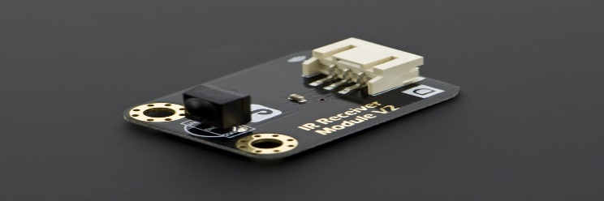

IR Receiver Circuit

1. **LDR circuit:**

A Light Dependent Resistor or a photo resistor is a device whose resistivity is a function of incident electromagnetic radiation. Hence, they are light sensitive device. LDR are light dependent whose resistance is decreased when light falls on it and then is increased in the dark.

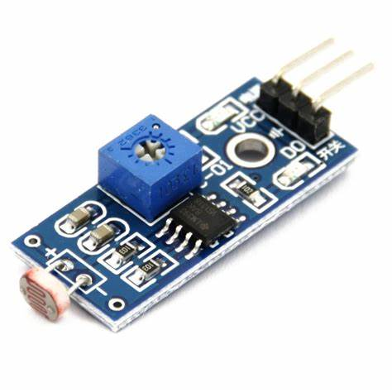

LDR

1. **Eye Led:**

LED is a semiconductor light source that emits when current flows through it. Electrons and hole in the semiconductor recombine and releasing energy in the form of photons. So, LED are used as eyes of the robot for attraction purpose.

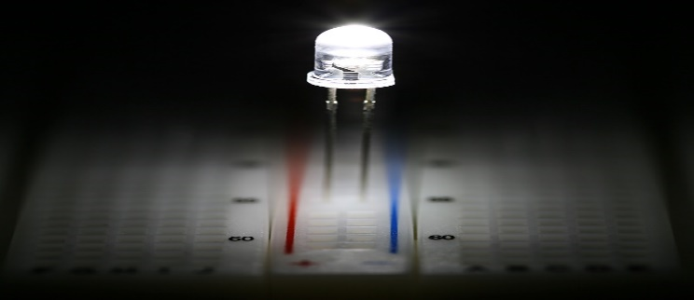

LED

1. **Debugging LED:**

Debugging is the process of finding and resolving defects or problems within a robot that prevents correct operation of robot or a system. To indicate the bug or issue in the robot, LED starts indication until the bug solved.

1. RF Receiver :

RF receiver receives the modulated RF signal and demodulates it. There are two type of receiver modules: superheterodyne receivers and superregenerative receivers. RF system communication use 433MHz frequency and don’t require “line of sight”.

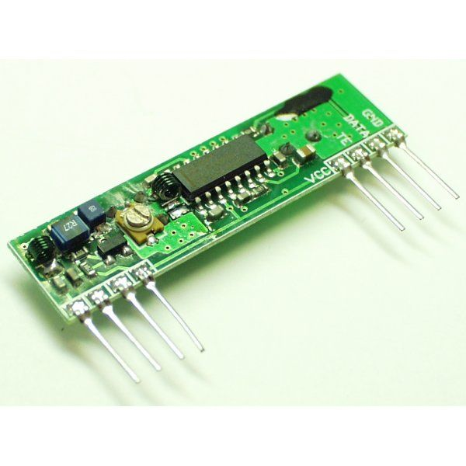

RF Receiver Circuit

The Components of Slate are,

1. Slider
   1. IR Transmitter
   2. IR Receiver
2. Arduino
3. RF Transmitter
4. Error LED
5. Switch Board
6. **Slider:**

The sliding mechanical motion converts all command of the slate to the controller. These tokens are placed on slate in the order which you want the program to run then slide “The slider” on top of it from left hand side to the right which then sends the same information to the Arduino which does the compilation work and will then transmits this program using the 433Mhz RF module to the bot where it executes the same. Slider consists of two parts: IR transmitter array & IR receiver array. These two are arranged in such a way that both slide on the slate at the top and bottom at the same time. When scanning has started the transmitter sends the IR rays and receiver receives the IR from the hole arrangement made on the tokens And then based on the matrix of data received the slider, the controller coverts this data into the pre programmed keywords which is then sent to the RF transmitter which then send it to the bot.

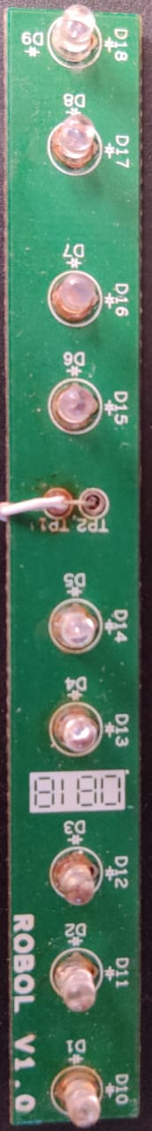

* 1. 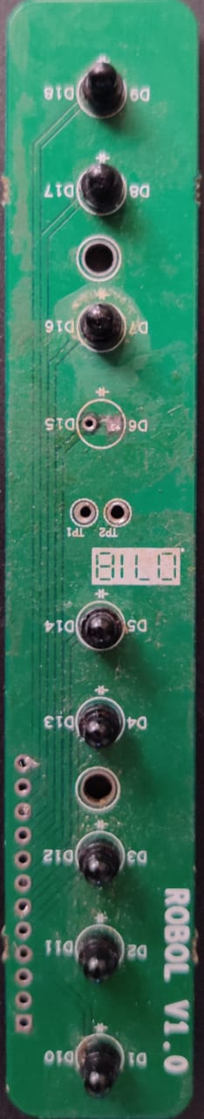**IR Transmitter :**

1.**2 IR Receiver:**

1. **Arduino:**

Arduino is open source hardware and software company, project and user community that designs and manufactures single board microcontrollers and microcontroller kits for building digital devices. The Arduino board provide 14 digital I/O pins and 6 analog pins with 5 V linear Regulator and 16 MHz Crystal oscillator. Here we required Arduino MEGA. It is designed for more complex projects. With 54 digital I/O pins, 16 analog inputs and a larger space for your sketch it is the recommended board for 3D printers and robotics projects.

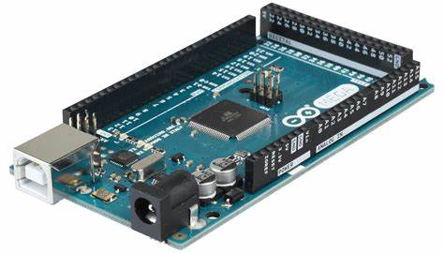

Arduino MEGA

1. **RF Transmitter:**

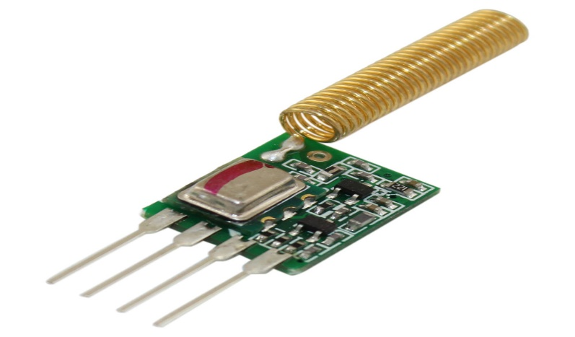 An RF transmitter module is a small PCB sub assembly capable of transmitting a radio waves and modulating that wave to carry data. Transmitter modules are usalluy implemented alongside a microcontroller which will provide data to the module to be transmitted. RF transmitters are usually subject to regulatory requirements which dictate the maximum allowable transmitter power output, harmonics and band edge requirements.

RF Transmitter

1. **Error LED:**

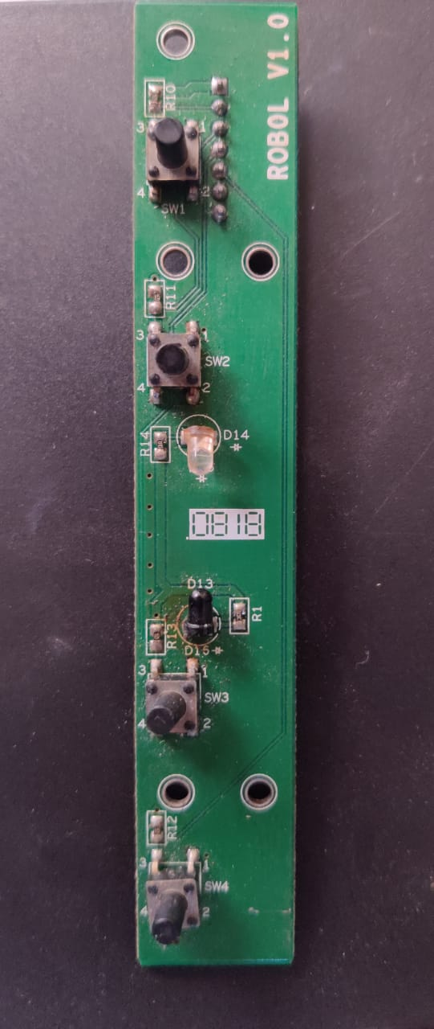 When Sliding happen, the controller keep checking for an error in every matrix. If there is a bug, error led start blinking. The error led circuit consists of eight indication LED in parallel way.

1. **Switch Board:**

Switch board is one of the command board of the slate system. Each switch consists of predefined command ensured in controller of the robot. It consists of four pushbutton switches. They are rated at 1A, 120 V.

Switch Board